Many Pathways
to Recovery



For far too long we have knelt with bowed heads, not in humility or prayer, but in shame. Today, we stand as one—in our gratitude for the fruits of recovery and in our commitment to service. Today, we stand to write the future of addiction recovery in America.

~ William L. White

Overview & Objectives

Many Pathways to Recovery can be one of the more controversial of the modules. Historically, treatment methods and self-help groups were few and people seeking support were often criticized for expressing their uniqueness. Many people are also resistant to change.

There is a great deal of information to support how highly personalized the recovery path is for each individual. Throughout this module students will examine evidence that supports the importance of allowing the person in recovery to explore the pathways best suited for them, rather than those which feel comfortable.

It is important to remember that we do have the right to our personal opinion regarding the “right” way to recover when we are the person in recovery; however, as professionals in the addiction and recovery arena, our professional role is to assist a person along the path which fits their needs – not our own.

Objectives

- State 3 reasons a person’s pathway in recovery is unique;
- Identify 2 barriers to accessing services a person who needs treatment might face;
- Recognize 2 mutual aid supports available to people in recovery; and
- Recall at least 3 pathways to recovery discussed in this module

Ask Yourself
- What do I consider the “right” way to recover?
- How often do I direct people seeking or in recovery down the same path I have traveled?
- Do I think in terms of black and white when it comes to the correct recovery pathway?
- Do I allow room for medication-assisted recovery to fall into my view of recovery?



Different Pathways
Not every person seeking recovery is able to or even needs to be admitted into a traditional treatment program. There are a number of other options in which people successfully engage. There are countless reasons a person may encounter barriers to participating in clinical services.

Some of those barriers could be:

- uninsured or unable to pay out of pocket for services;
- unable to take time away from work;
- unsupportive family;
- not meeting clinical criteria for admission;
- no access to services; or
- simply not fitting into a particular treatment milieu.

When discussing the idea of different pathways to and in recovery, what works for one person may or may not work for another. Based on a qualitative research study funded by the Center for Substance Abuse Treatment (CSAT) people with sustained recovery report using a myriad of pathways. Those will be examined in this module.

View the PDF, Pathways to Healing and Recovery: Perspectives from Individuals with Histories of Alcohol and Other Drug Problems for the entire study.

Clinical Services

Licensed treatment centers in Texas provide different levels of clinical care. To be admitted to any of the levels, a person must meet diagnostic criteria. Those include Detoxification, Residential, Outpatient, and Individual Therapy.

Detoxification is primarily provided to people who have acute intoxication and withdrawal from substances. Being admitted into this supervised environment, a person may avoid the life-threatening complications potential during detoxification from some substances.

Residential treatment programs provide for 24-hour supervision and intensive programming for a person with Substance Use Disorder. Residential treatment centers specialize in addiction and are often housed in non-hospital locations. A client in this level of care are provided education, life skills, family counseling, group counseling, individual counseling, and structured leisure activities.

When someone refers to “inpatient treatment”, they are likely referring to treatment involving co-occurring disorders.

Outpatient Group occurs when a client does not live at the location of services. A person involved in outpatient services should have enough stability to engage in a less structured program for fewer hours per day than someone in residential services. A client in this level of care receives education, life skills, individual counseling, group counseling, and other support for sustaining recovery.

Individual Therapy is also a recovery support used by many people in recovery

Non-Clinical Services

The time immediately following treatment is crucial to maintaining recovery. Some of the supports a person leaving treatment might consider are Recovery Residences and Peer Recovery Support.

Recovery Residences

Recovery residences are referred to as sober homes, sober living, transitional living, and even halfway houses. Recovery residences bring people together who desire to live a life in recovery. The residences practice their newly established recovery, while benefiting from the support of a home with rules and other requirements of accountability. They are often viewed as a transition from treatment. Sober homes vary in their support and efficacy. This is likely due to sober homes not being licensed as treatment programs are.

Peer Recovery Support

Peer recovery support can be a vital component of maintaining long-term recovery. Peers are able to provide support that are unable to be provided by counselors. A peer relationship can increase the likelihood of a person sustaining recovery following treatment. SAMHSA outlines the benefits and types of supports provided through peer support in Peer Support and Social Inclusion

The Texas Certification Board of Addiction Professionals (TCBAP) designates two types of peer recovery support:
- Peer Mentor / Peer Recovery Coach Designation (PM/PRC)
- Peer Recovery Support Specialist (PRS)

To 12-Step or Not to 12-Step?

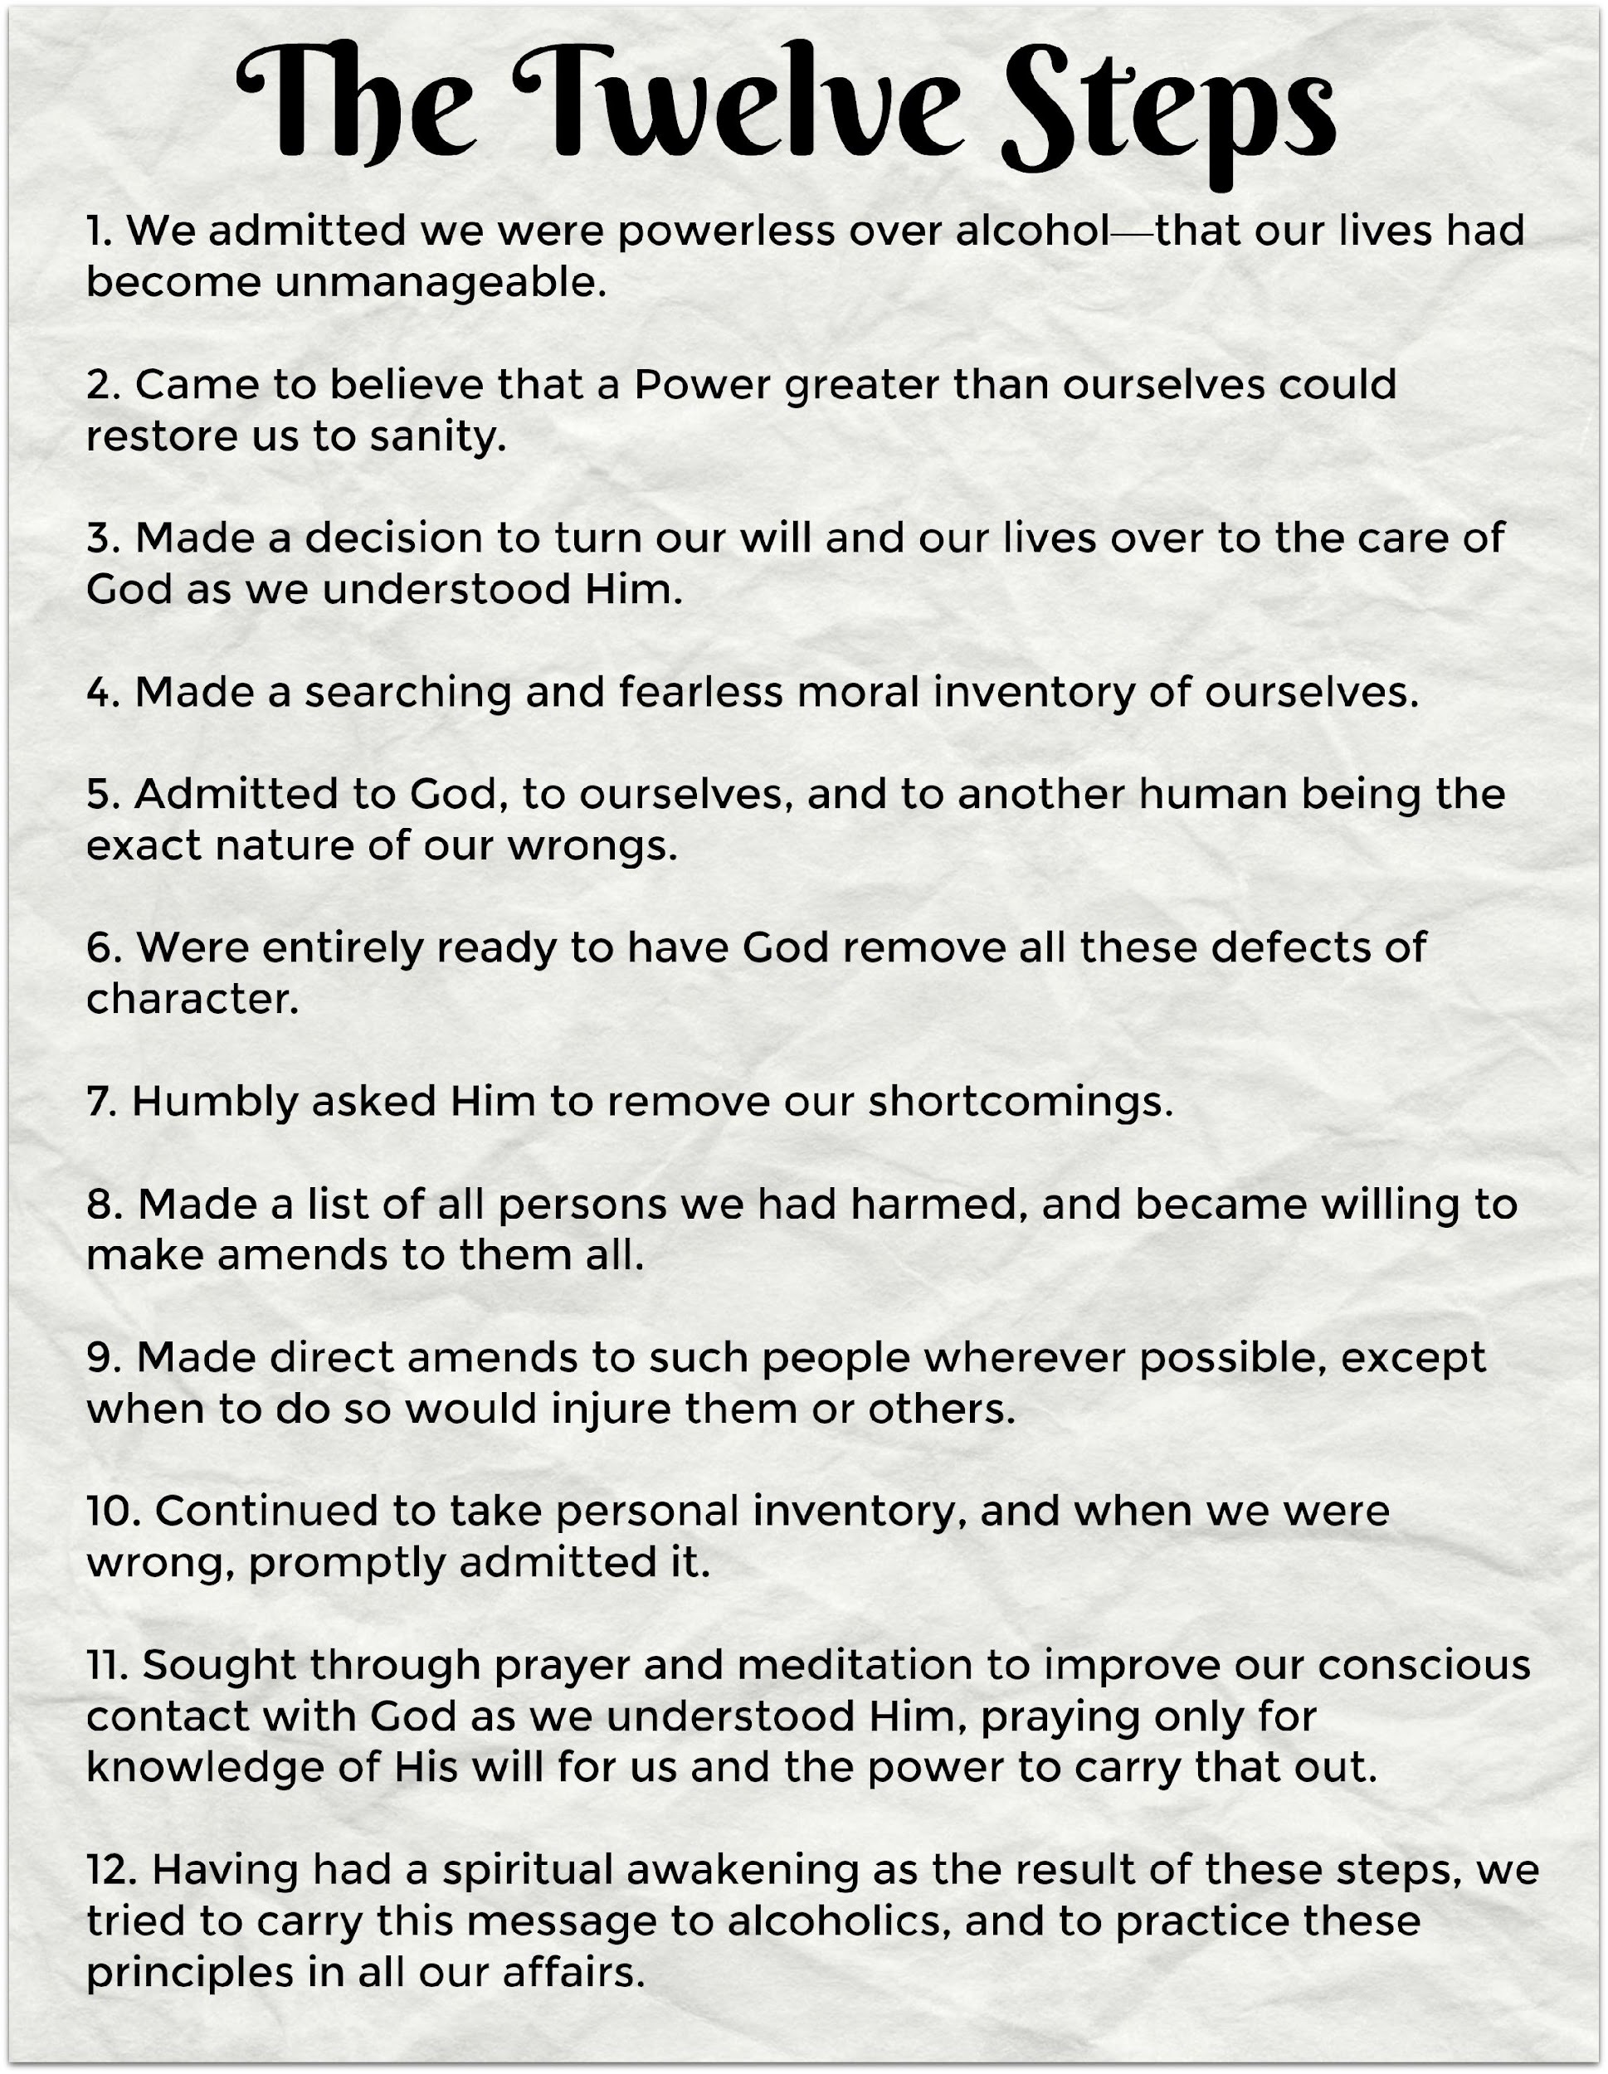

When choosing treatment or support services, there are many options. A first-time consumer may not know what to look for. A helping professional can guide people to make the best decisions by being as informed as possible.
On their website, Recovery.org describes the differences between 12-Step programs and non-12 Step programs.

 | 12-Step Programs | Non-12-Step Programs
Philosophy | Have a religious or spiritual component and mention “God” in the 12 steps to recovery. | Typically approach addiction from a scientific or psychological perspective.
Group vs. Individual | Have a group mentality, in which members share experiences and help each other achieve and maintain sobriety. Generally, has a sponsorship program. | Although they have a group environment, the focus is on finding which strategy works for you and developing those skills.
Open vs. Closed Meetings | Often have open meetings for anyone to attend, as well as some closed, in which only 12-step members or prospective members are allowed to attend. | Differ from program to program, but meetings are typically open unless listed as “closed.”
Cost | Meetings are free to attend. The only requirement is that you wish to stop drinking or using drugs. Costs of residential treatment incorporating a 12-step philosophy will vary. | Meetings are also free. Costs of residential programs using a non-12-step approach to recovery will vary.
Length of Treatment | Don’t have a set length of treatment. Some people attend meetings for a few months while others attend for life. Standard length of residential treatment programs with 12-step components will vary – typically 30, 60 or 90 days. | In terms of meeting attendance, these are similar to 12-step programs in that there is no set period of membership. Non-12-step residential recovery programs have varying treatment lengths.
Confidentiality | Are completely confidential and will never reveal your identity or personal information. | Also take confidentiality very seriously and will never divulge your identity or personal information.
Family Support | Typically have support groups for families such as Al-Anon and Nar-Anon. | SMART Recovery has a support group designed to support families and friends of addicted individuals.
Treatment Approach | Require that you complete a series of 12 steps based on powerlessness and embracing God or a higher power. The approach has no scientific basis, but it has helped many. | Use evidence-based, scientific approaches to treat addiction and constantly evolve as scientific knowledge evolves.
Faith-Based Recovery Supports

Faith Based Recovery is important to many people in recovery. This can include attending weekly services at his or her place of worship; a fellowship; or even a group that meets to study the principles of the faith.

Faith Based Recovery can also include formal mutual aid support meetings below:

- Addictions Victorious is a non-denominational recovery program with focus on Christ. This program is not yet available in Texas.
- Alcoholic’s Victorious is a 12-step program for people in recovery who recognize “Jesus Christ as their Higher Power”.
- Alcoholics for Christ is Jesus-centered and provides support for those with addiction who are seeking recovery, family members of people with addiction, and those who are now adults who grew up in homes with addiction.
- Buddhist Recovery Network (2008) focused on recovery through use of Buddhist principles, mindfulness, and meditation.
- The Calix Society is described as, “Calix is an association of Catholic alcoholics who are maintaining their sobriety through affiliation with and participation in the Fellowship of Alcoholics Anonymous”.
- Celebrate Recovery (CR) (Founded in 1990) is a 12-step program that originated from Saddle Back Church in California. CR supports people in recovery from any addiction, including process disorders. A person working this program will identify himself or herself as a believer of Christ who is struggling with an addiction, rather than by the addiction alone.
- Christians for Recovery engages in active discussions based on the bible.
- Jewish Alcoholics, Chemically Dependent Persons and Significant Others (JACS) is a recovery community for Jewish people in recovery.
- Millati Islami is a 12-step program based on Islamic principles and in accordance to the Islamic way of life.
- Life Recovery groups
- Overcomers Outreach is a 12-step program based on scripture. Addressed in Overcomers are mental health, addiction, and other difficulties.
- RU Recovery is biblically based on Christian recovery and has chapters already established in Texas.
- The National Association for Christian Recovery is not a recovery program but a referral source for Christian based recovery meetings. Their website has an extensive list of options.

Secular Recovery Supports

- AA Agnostica designed for those “disturbed by the religious content in AA meetings”.
- Life Ring Secular Recovery emphases “human effort rather than divine intervention”.
- Recovery is a mindfulness practice based on Buddhist philosophy.
- Secular AA’s website describes their program: “We are an International Organisation that supports the Agnostic, Atheist and Freethinker in AA. Our purpose is to stay sober and help other alcoholics achieve sobriety, to widen the gateway to recovery, and to help make AA ever more inclusive.”
- Secular Organizations for Sobriety has guidelines, rather than structure and focuses on personal responsibility.
- SMART Recovery is increasing in availability. Based on Cognitive-Behavioral Theory, SMART Recovery’s website specifies they are “not a spin-off of AA”. The program can help a participant gain awareness and change behaviors. This mutual aid program does not ask members to introduce themselves as “addict” or “alcoholic”.
- Women for Sobriety focuses on the specific needs unique to women.
- 16-Step Empowerment groups have online resources and groups either meeting or currently being created in Texas.

An Interview about Moderation Management

In 2002 Bill White visited the New York City offices of MM and had an opportunity to interview key figures of the program, including Ana Kosok. In 2013 he was able to interview Ana Kosok again and she spoke about the evolution of MM.

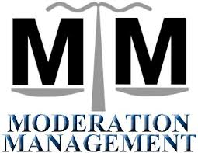

A SMART Recovery Video
UNT Professor Dr. Justin Watts is trained as a SMART Recovery facilitator and was involved in recovery research at Penn State. He shares about SMART Recovery with Carrie Breedlove, RTP Program Coordinator, in this YouTube video.
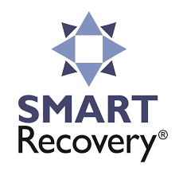

Gender Specific
Many groups have gender-specific meetings.

- AA and NA traditionally have gender specific meetings as part of their regular schedule.
- Women for Sobriety



Bodywork

Bodywork is most often used by people in recovery to assist with meditation and deeper thinking.

Examples of bodywork might include:
- Energy work and Energy Healing such as Acupuncture, Acupressure, Chakra Healing, Reflexology, Reiki, and Smudging. Counselors in Texas are eligible to complete training and certification for Acudetox, which is similar to Acupuncture, focusing solely on decreasing detoxification symptoms;
- Massage;
- Traditional Chinese Medicine; and
- Yoga



Culturally Based Recovery
Culture plays a part in the recovery of many individuals. Often, people in recovery explore their familial roots, traditions, and values along the recovery journey. The diversity of culture and experience bring another unique element to the path of each person. Some cultures are steeped in addiction history. It is important to be aware of the impact that has on a person seeking or in recovery.

A person in recovery interviewed during the Recovery to Practice (RTP) development summed up the unique needs each person has in recovery as, “In order to sustain my recovery for the long-term it was important that I find my tribe, my people”. This interviewee discussed how important having a safe place to belong is for her. She took many areas of her culture into account in order to find that security.

Many sociological elements also impact an individual in recovery. Culture may include a person’s age; socioeconomic class; gender; profession; sexual orientation and more. You can read more about culture and addiction in Recovery from Addiction: Becoming Aware of Cultural Influences by A. Tom Horvath, Ph.D., ABPP, Kaushik Misra, Ph.D., Amy K. Epner, Ph.D., and Galen Morgan Cooper, Ph.D., edited by C. E. Zupanick, Psy.D.

Cultural Recovery groups were cited work by Bill White pointing out the first Mutual Aid Society called Sober Circles were created in the 1750’s by Native Americans to provide support for people in recovery.

Other examples of cultural ceremonies that may support a person’s recovery today could include:
- Native American Sweat Lodges;
- Chinese Medicine; and
- White Bison Wellbriety

Support for the Justice Involved
SOS Behind Bars is a secular recovery focused support with in-person meetings in jails and prisons.
Specialty Courts were first developed in Miami, Florida in 1989. The courts are shown to reduce substance use and recidivism. Judge Larry Gist in Jefferson County started the first drug court in Texas in 1993. The Texas Association of Specialty Courts (TASC) oversees the specialty courts in Texas.
Currently, in Texas, these programs include:
- Drug Court;
- DWI Court;
- Mental Health Court; and
- Veterans Court.
This Texas Drug Courts handout can provide a brief and bullet pointed view of how Drug Courts work in Texas.
Therapeutic Communities: From 1991 – 1995, the 45th Governor of Texas was Ann Richards. She was outspoken about her own recovery and was a strong advocate for getting treatment into the Texas prison system. Therapeutic Communities in the Texas prison system were implemented in large part because of her advocacy for treating, rather than punishing a person with addiction.
Individuals on probation enter into Substance Abuse Felony Punishment Facility (SAFPF), a 6-9-month residential treatment inside a state jail or prison.

Qualified individuals already incarcerated in prison may enter into In-Prison Therapeutic Community (IPTC) for 6-9 months of residential treatment.

Incarcerated offenders with more severe substance use disorder diagnosis may enter into a Pre-Release Therapeutic Community (PRTC) for 6 months or intensive residential treatment prior to their release.

View the prison and state jail units throughout Texas with such programs.

PBS airs a series program called, “Live Here”. In this 27-minute episode the show goes inside a Drug Court.

Governor Richard’s memoir, Straight from the Heart: My life in politics & other places is available through Simon & Schuster.

Recovery Schools

Many collegiate-aged students who complete treatment believe attending college will jeopardize his or her recovery. It stands to reason a person attempting to maintain recovery might think a college campus could cause harm to their stability given students' staggering involvement in college drinking.

There are now options for people in recovery to continue recovery while attending college. Collegiate Recovery Programs (CRP) began at Brown University in 1977. Texas Tech began the first CRP in Texas in 1986. The University of North Texas (UNT) has the first fully integrated behavioral health CRP in the country. The CRP at UNT offers daily meetings, course credit for seminar attendance, intramural sports teams, case management, peer recovery coaching, employment opportunities, travel, service opportunities, and recovery housing on campus.

If you are thinking of starting a CRP, contact the Association of Recovery in Higher Education (AHRE). The organization offers resources and assistance.

Executive Producer Greg Williams explores the largest sober high school in the world – located in Houston, Texas – in his documentary Generation Found.

Sarah Nerad is one of the founding members of Young People in Recovery (YPR) and is well known in the Recovery Schools arena. She shared about her CRP experience in this Ted Talk.


Tele-therapy

Delivery of professional services via telephone or video chat. Can be beneficial
for people in rural areas,
those who travel a great deal, or
those with conditions prohibiting or limiting their mobility.
Multi-Media Support

There is a great deal of information about addiction and recovery now available through various media outlets. This more mainstream avenue might reach people who need a better understanding of recovery that would not otherwise seek or be exposed to the information. Some of the below resources can be easily found and of use without a great deal of commitment, exposure, time, or money.



There is an App for That!

As long as you are using your mobile device, why not allow it to help you in recovery?

Here are only a few of the apps available specific to recovery or supportive of accountability in other areas of life. Click on the image for the link to the app.

  Sober Grid  (support) |   Nomo  (recovery tracking) |   Flipd  (focus)
  Squirrel Recovery  (support) | 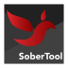  SoberTool  (recovery tracking) |   MindShift (anxiety)
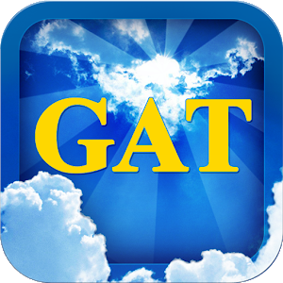  Gambler’s Anonymous  (tool kit) |   Quit That!  (tracker) | 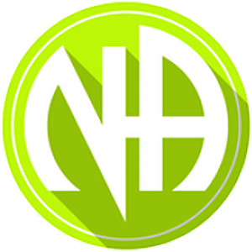  Just for Today  (inspiration)
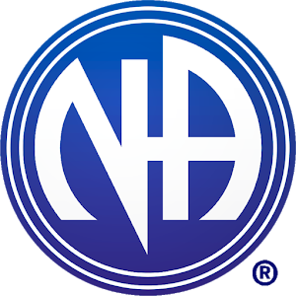  NA meeting finder | 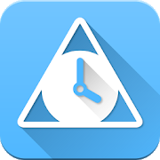  SoberTime  (recovery tracking) | 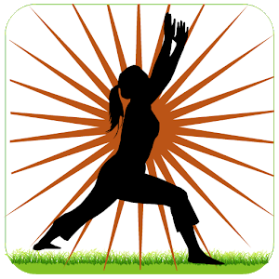  Surya Namaskar (yoga)
  AA Big Book | 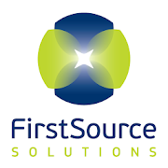  FirstSource  (recovery tracking) |   Mindfulness (meditation)
  Addicaid  (meeting directory & accountability) |   AA Meeting locator | 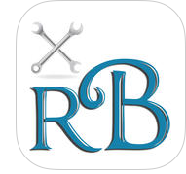  recoveryBox  (accountability)
PTSD Coach | 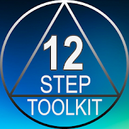  12 Step Toolkit |   Today’s Step

Hazelden-Betty Ford has many apps of their own, including daily meditations, inspiration, and continuing care.

Documentaries

Documentaries and films pertaining to recovery should be viewed with caution due to potential triggers.

Addiction

In 2007 HBO made this 1 hour and 30 minute film. The documentary is broken into the following nine segments:
- Saturday Night in a Dallas ER
- A Mother’s Desperation
- The Science of Relapse
- The Adolescent Addict
- Brain Imaging
- Opiate Addiction: A New Medication
- Topiramate: A Clinical Trial for Alcoholism
- Steamfitters Local Union 638
- Insurance Woes

Anonymous People is the first film to discuss sharing about personal recovery without violating principles of 12-step programs. This film was made by a man in recovery and involves many well-known people who publicly speak about their recovery. You can view the trailer to the film through YouTube.

Drugs, Inc. Currently in the 7th season, National Geographic has a documentary series addressing illegal substances from the side of drug traffickers and dealers.

Generation Found Executive Producer, Greg Williams, is the man who made Anonymous People. This documentary focuses on the largest sober high school in the world located in Houston, Texas.

Marijuana: A Second Class Addiction explores marijuana addiction with information and interviews from people with this addiction and recovery.

Montana Meth looks at the psychological and physical effects of using methamphetamine. While this is not in Texas, The Montana Meth Project website has a number of resources.

Old Before My Time addresses the effects of use on brain structure and functioning.

Overtaken is a documentary addressing teenage prescription pill addiction.

Russell Brand from Addiction to Recovery (2012) is a 1-hour movie about the addiction and recovery of actor, writer, and author, Russell Brand. In this film, he also talks about the death of Amy Winehouse. The film can be found on most streaming services. You can view the trailer through this YouTube link. His website also has a dedicated page for recovery information, including: his book, podcasts, and film links.

The House I live in addresses the war on drugs from an educational standpoint.

The War on Drugs (2014) is a documentary by Russell Brand, with the British Broadcasting Corporation (BBC), exploring the criminalization of drugs.

Music


Recovery oriented music is not hard to find because of the number of entertainers who are in recovery.

Steven Tyler and Joe Walsh both performed and shared about their personal recovery in Washington, D.C. for the Unite to Face Addiction Rally.

Elton John, Eric Clapton, Anthony Keidis, Eminem, and Justin Furstenfeld - to name a few - are open about their journey in recovery.

Joseph Gorordo, Licensed Chemical Dependency Counselor (LCDC); President of the Austin Chapter of Texas Association of Addiction Professionals (TAAP); and the Director of Outreach for Recovery Unplugged.

Recovery Unplugged has locations in Virginia, Florida, and Texas. The Texas program is located in Austin. Recovery Unplugged in Austin offers detoxification, residential, and outpatient treatment to individuals impacted by addiction through music-based treatment.

Joseph visited the Dallas Chapter of TAAP in January 2018 to present: Music is Medicine: Incorporating music into clinical practice!

Comedy



Recovery Comedy is composed of comedians in recovery performing standups related to addiction and recovery. In this troupe there are 18 comedians.

Entertainers who are open about their recovery not only provide people with recovery enjoyment through their art, they are also in a position to help decrease stigma.

Podcasts

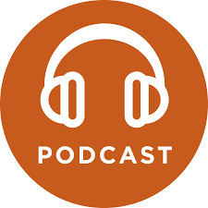

Because the Internet is easily accessible, Podcasts have become popular. A Podcast is an audio recording onto a digital file that is made available on computers and smartphones. Recovery related podcasts are available to listen to or download for future use. Click the image to be taken to the podcast.

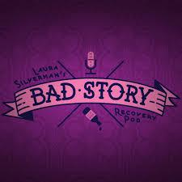

Bad Story explores addiction and mental health recovery.

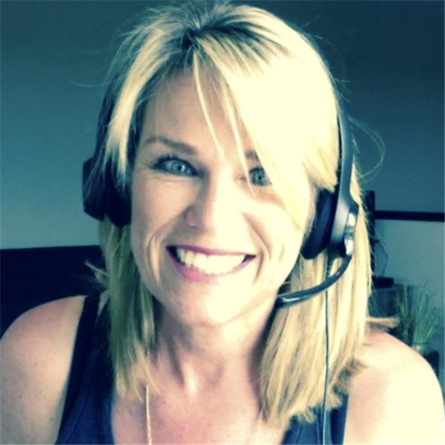

The Bubble Hour is hosted by a stigma-breaking woman in recovery.

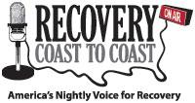

Recovery Coast to Coast is aired for 2-hours every weeknight.
Recovery Coast to Coast is also streamed online through a Clear Channel Radio station out of Seattle.



Recovery People focuses on individuals in recovery and their family members.

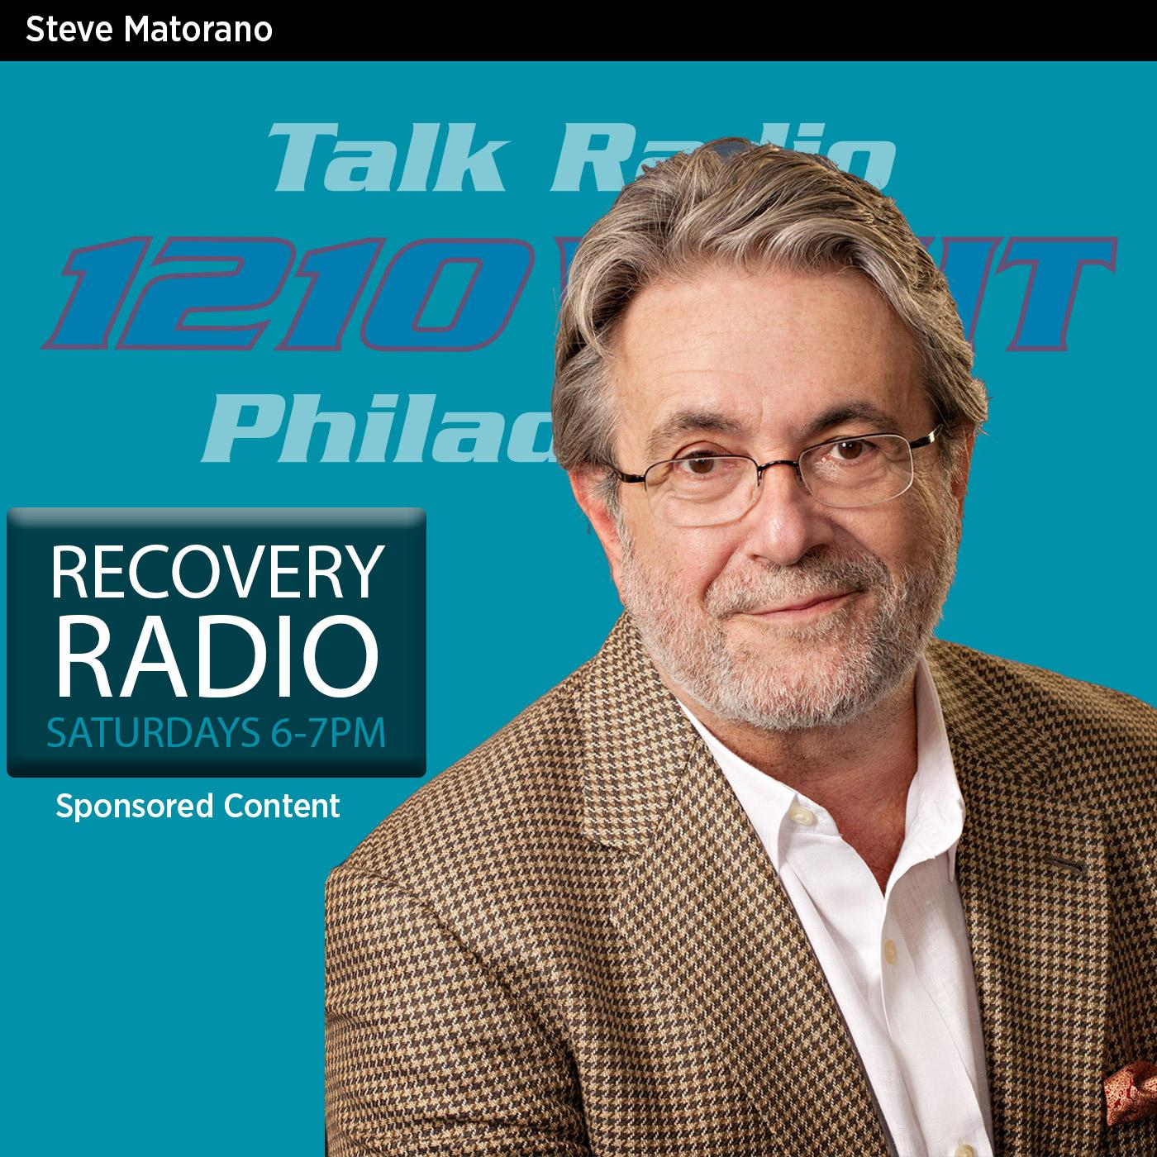

Recovery Radio educates listeners about addiction.

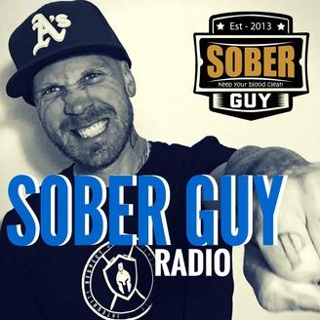

That Sober Guy finds the positive in recovery from addiction.

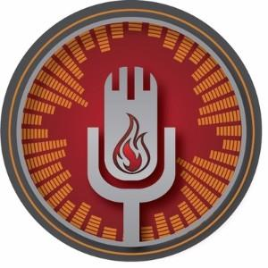

Voices of Recovery is described as a podcast for recovery advocates.
Conference Speakers

Noah Levine is a Founding Teacher, author of Dharma Punx, Against the Stream, The Heart of the Revolution and Refuge Recovery, is a Buddhist teacher, and counselor. He has created a Buddhist approach to addiction recovery called Refuge Recovery that includes peer lead meetings as well as a professional treatment center. He is also the founding teacher of Against the Stream Buddhist Meditation Society, with centers in Los Angeles and San Francisco and over 20 affiliated groups around North America. He teaches meditation classes, workshops and retreats internationally. Noah holds a Master’s degree in counseling psychology and lives in Los Angeles.

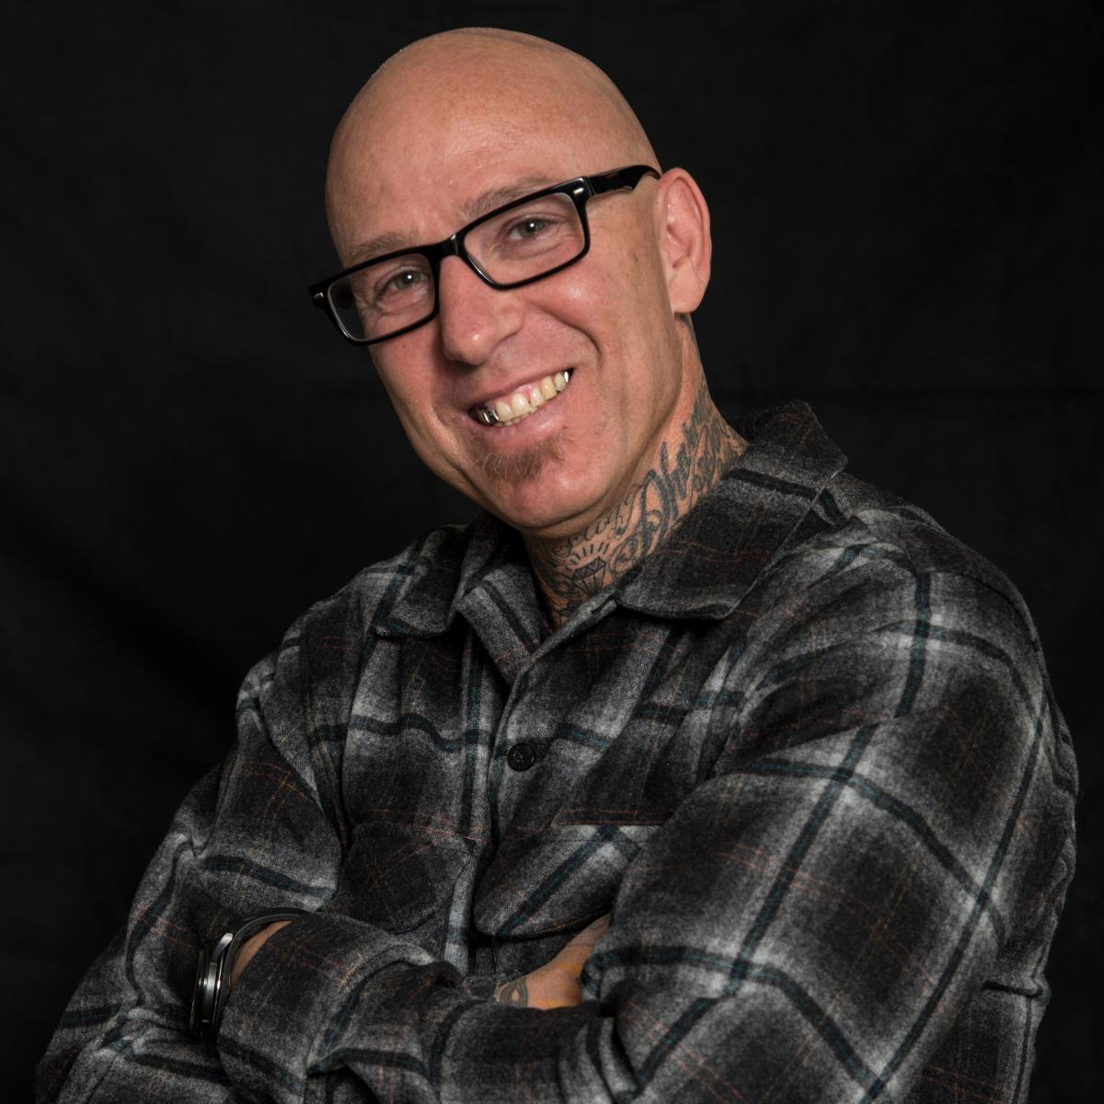

During the 5th Annual Recovery Conference at The University of North Texas, Noah provided insight into Refuge Recovery.

Trent Shelton was born in Little Rock, Arkansas and raised in Fort Worth, Texas. As a child, all Trent wanted to be when he grew up was a professional football player. While he achieved his childhood dream, the former NFL player’s career was a shaky one where he felt incomplete while constantly chasing after worldly things to temporarily fulfill the voids in his life. It wasn’t until Trent hit his lowest point, after being released from multiple NFL teams along with the birth of his son that he decided to work on becoming the best person he could be.

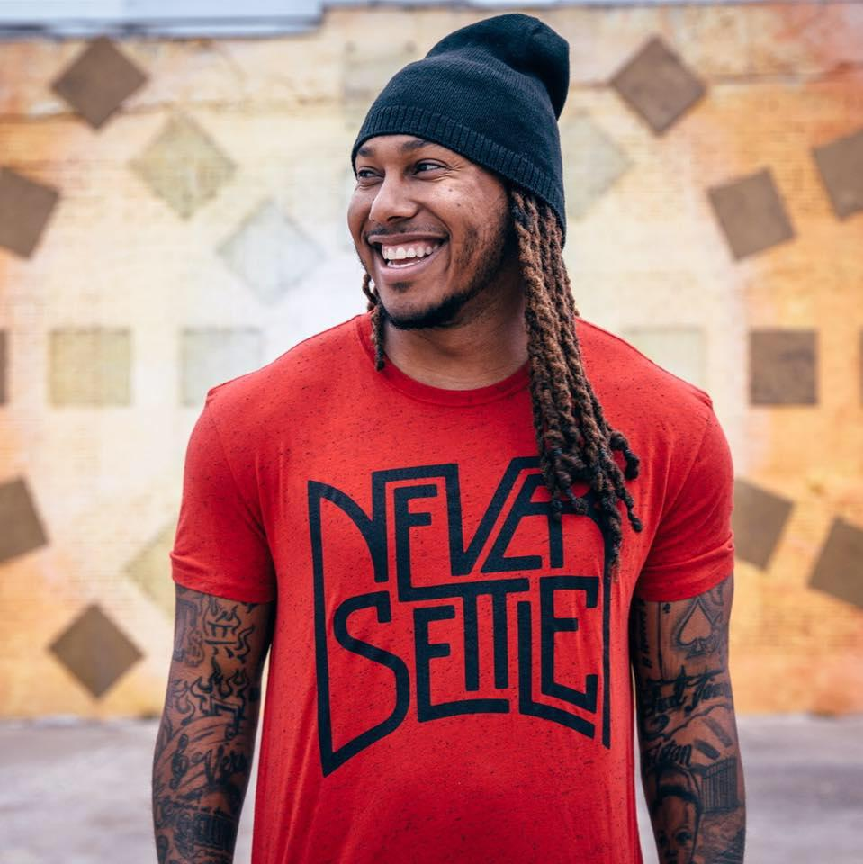

In March of 2009, Trent picked up his iPhone and started sharing two-minute videos of his progress as a means of helping him stay accountable while bettering his life. He ended each of his videos with “It’s RehabTime.” A couple years later, those two-minute videos evolved into Rehab Time Organization, a 501(c)3 nonprofit with a mission to promote change for the better by uplifting, empowering, and demonstrating that "change starts with you," from the inside out, through the development of faith, self, fitness, relationships and leadership. Today, on average, Trent reaches over 35 million people a week through his daily messages and videos. The motivational speaker has over 3 million Facebook fans, over 350k Instagram followers, and over 200k Twitter followers.

During the 5th Annual Recovery Conference at The University of North Texas, Trent shared a bit of his story and motivation.

Social Media

There are many social media platforms to support every type of recovery that exists.

Treatment centers using social media private rooms to keep their alumni connected.

Juggling the Jenkins is a blog and Facebook page run by a woman who talks about the struggles she has experienced.

Review the blog entry through the Minnesota Recovery Connection, Social Media and Recovery: The New Frontier

It isn’t Self-Help

Mutual aid groups were once called self-help groups. The terminology changed to now be called mutual aid programs to clear up the misnomer of people in recovery working a program alone. The fellowship of the program was often noted in the CSTAT study as being significantly important to those responding. Therefore, it is easy to understand how vital peer-to-peer relationships are in recovery. Having so many mutual aid programs opens up many pathways, instead of assuming a one size fits all for recovery.

An extensive and frequently updated list of mutual aid groups can be found through the Faces and Voices of Recovery website.



12-Steps

Founded in 1935, the most well-known and initial 12-Step program is Alcoholics Anonymous (AA). 12-Step programs created after AA are based on those 12-steps yet altered a bit to fit the primary purpose of each group. Narcotics Anonymous (NA) followed in 1953. At the time of creation, NA was known as Addicts Anonymous, but changed their name to Narcotics Anonymous later to avoid being confused with the original AA - Alcoholics Anonymous.

Writings documenting the history of AA indicate 180 nations have AA groups and membership worldwide is estimated to be more than two million. The history of AA is well documented and highly recommended for review. Works detailing the history of NA indicate, “In 2007, there were over 25,065 groups holding over 43,900 weekly meetings in 127 countries” (History of NA, n.d.).

A majority of the participants in the CSAT study indicated that even if they no longer attend 12-Step programs, at one time in their history they have. Some of the reasons, it appears, for so many in recovery to have at least been exposed to a 12-step based program at some point in their recovery is due to the availability of the program and the fellowship offered.

A variety of 12-step based groups are described below. These are listed alphabetically.
- Alcoholics Anonymous (AA) is described above.
- AA Agnositca is a 12-step group described by their website as being for those, “disturbed by the religious content of many AA meetings”.
- Adult Children of Alcoholics (ACOA) is a 12-step meeting for those who grew up alcoholic or otherwise dysfunctional homes.
- 12-step support for methadone participants is referred to as Methadone Anonymous. A website was provided but appears no longer be active. The description for this 12-step group described people in recovery who use medication assistance as part of their pathway but have been turned away from traditional 12-step meetings.
- Al-Anon (Founded in 1955) is a group for those who are “worried about someone who has a drinking problem”.
- Alcoholic’s Victorious (Founded in 1948) is a 12-step program for people in recovery who recognize “Jesus Christ as their Higher Power”.
- All Addictions Anonymous (AAA) uses the original 12-steps fashioned for people in recovery from all addictions.
- Compulsive Eaters Anonymous – HOW (CEA-HOW) is a 12-step program for people with compulsive eating.
- The Calix Society (Founded in 1948) is described as, “Calix is an association of Catholic alcoholics who are maintaining their sobriety through affiliation with and participation in the Fellowship of Alcoholics Anonymous”.
- Co-Anon Family Groups are for family members and close friends of those who have a problem with cocaine.
- Cocaine Anonymous (CA) was founded in 1982 and is a program specific to those in recovery from cocaine addiction.
- Crystal Meth Anonymous (Founded in 2000) is for those who are in recovery from methamphetamine addiction.
- Depressed Anonymous (DA) provides 12-step support for people in recovery from depression. DA also helps to educate the public about depression.
- Dual Recovery Online is a 12-step program for people who have mental health disorders and addictions.
- Emotions Anonymous (EA) was founded in 1971 and wass designed for people in recovery from emotional difficulties.
- Families Anonymous (FA) are for family members of those who have substance use or behavioral problems. No website could be located for Families Anonymous.
- Gam-Anon Family Groups (Founded in 1960) is a 12-step fellowship for those who have loved ones with problem gambling.
- Heroin Anonymous (Founded in 2004) is solely concerned with a person recovering from heroin addiction.
- In the Rooms is the largest online recovery community offering over 100 recovery meetings each week.
- Marijuana Anonymous offers in person and online 12-step fellowship for those seeking or in recovery from marijuana addiction.
- Nar-Anon Family Groups are described as support for friends and relatives of those with addiction.
- Narcotics Anonymous (NA) is a 12-step program for those in or seeking recovery from drug addiction.
- Nicotine Anonymous (NICA) was founded in 1980 and was designed as a program for those with a desire to stop using nicotine.
- Opiates Anonymous is a fellowship for those people in recovery or seeking recovery for use of opiates.
- Overeaters Anonymous (OA) is a 12- step program for people who have problems with food, including compulsive overeating, under-eating, food addiction, anorexia, bulimia, binge eating, or over-exercising.
- Recoveries Anonymous (RA) is described as a solution-focused program for all problem behaviors.
- Recovering Couples Anonymous is for couples in recovery with a desire to stay committed to their relationship in their recovery.
- Sober24 is an active online community offering recovery management software and other recovery related literature.

Does NA Work?

The results of a 2013 Narcotic’s Anonymous Membership Survey, indicates membership most commonly improves family relationships, social connections and hobbies.
The more robust results of the survey can be seen here.

Natural Recovery
Natural recovery can be described as recovery that takes place when a person uses no formal treatment, therapy, or specific interventions. This is often specified as the pathway of a lower number of people in recovery.

Online Support

As you have likely noticed, many of the pathways already discussed have online tools for use. While online meetings may not work for everyone, the practice of fellowship is made available with convenience through online interaction. Online meetings can be useful for many people in recovery. Online meetings can be an introduction to those who have not previously attended or just the support a person in recovery needs while traveling or living in a remote location.

Addiction Survivors provides a number of recovery resources online, including: communities for peer-to-peer interactions with people in recovery from similar substances as one another; treatment resources; chat forums; free educational material; and local meeting directories. The information is for those in recovery and those with loved ones in recovery or still in active addiction.

Personal Recovery Supports

Focusing only on one aspect of recovery (treatment, counseling, fellowship, or mutual- aid) would not be a clear perspective on what people in recovery engage in to feel supported and healthy. It is possible you might not have considered some of these day-to-day activities as being part of successful recovery.

A number of people in recovery were asked to share important parts of their recovery. As many pathways as people interviewed were shared. Many have shared some of the smaller activities they find supportive of their journey in recovery. Some of them were:
- Personal Development books and workbooks;
- Life Enrichment Seminars and Workshops;
- Classes at Church;
- Art class;
- Riding horses;
- Medication assisted recovery; and
- Cooking classes.

Guided Meditation | “Not simply sitting alone with my own thoughts. I participate in a weekly mediation by a practitioner of mediation”.
Yoga | “I take a bit of time out for myself each day to do yoga. I am not an expert. There are times I cannot even get into the poses. But, the moments for me really seem to ground me and keep me focused on staying healthy”.
Church | “I have a wonderful church home I found in recovery. I attend every week to get connected”.
Bible study | “It isn’t only the scripture, but the other men in the group that helps me feel stable”.
Movie night with friends | “I have three very dear friends who are also in recovery. Once a month we have a movie night. We don’t even go out to a movie theater. We meet up at one of our apartments and enjoy the time together”.
Workshops | “Since I got into recovery, I have attended workshops in the community to learn new hobbies. I enjoy education and socializing with people in my neighborhood”.
Retreats | “My girlfriends and I take a retreat once a year. We rent a cabin that is only an hour from where we all live. We each bring an activity to do. Some bring arts and crafts. Others bring those little surveys that tell you something about your personality. We each cook a meal once during the weekend. We stay in our pajamas for hours as we drink coffee and catch up. We laugh, we cry. We catch our breath from the regularly busy lives we lead. Simply being together is the most important part. Even as we are driving away from the cabin, we begin looking forward to the time again next year”.
Apps | “This may be a sign of the times...but I use apps on my mobile phone. I use different ones for different needs but the biggest connection between all of them is they all help me stay accountable”.

A common theme that appears to run through the recovery supports discussed is an individualized pathway suited best for the person seeking recovery, in which he or she finds a safe and supportive place to belong.

An All-Inclusive Support

Created for professionals, peers, students, family members, and anyone interested in the UNT RTP Community of Practice on Facebook.

Additional Resources

Addiction Recovery Guide provides links to recovery support under several headings:

12-Step
Rational and Secular
Religious Based
Other

Recovery Websites

Faith Based Recovery Support Websites

Addictions Victorious http://www.addvicinc.org/

Alcoholic’s Victorious http://www.avictorious.org/

Alcoholics for Christ http://www.alcoholicsforchrist.com/

Buddhist Recovery Network http://www.buddhistrecovery.org/

The Calix Society https://www.calixsociety.org/

Celebrate Recovery http://www.celebraterecovery.com/

Christians for Recovery https://christians-in-recovery.org/

Jewish Alcoholics, Chemically Dependent Persons and Significant Others https://jewishboard.org/

Millati Islami http://www.millatiislami.org/Welcome/islamic-12-step-program

Life Recovery http://liferecoverygroups.com/

Overcomers Outreach http://overcomersoutreach.org/

RU Recovery https://rurecovery.com/

The National Association for Christian Recovery http://www.nacr.org/referral-center/finding-a-group

Women for Sobriety http://www.nacr.org/referral-center/finding-a-group

Secular Recovery Supports Websites

AA Agnostica https://aaagnostica.org/

Life Ring Secular Recovery https://lifering.org/

Refuge Recovery https://www.refugerecovery.org/

Secular AA https://secularaa.org/

Secular Organizations for Sobriety http://www.sossobriety.org/

SMART Recovery https://www.smartrecovery.org/

16-Step Empowerment groups http://charlottekasl.com/recovery-discovery-groups/

Gender Specific Recovery Supports Websites

Women for Sobriety http://www.nacr.org/referral-center/finding-a-group

Culturally Based Supports Websites

Wellbriety http://www.whitebison.org/

Other websites

The following website descriptions are stated as they are provided on their own website:

12 Step me. Org
www.12stepme.org
Your AA online chat (24/7) and online AA meeting destination (nightly 10pm EST/GMT -4) - 'Hope is spoken here.'
E-mailadmin@12stepme.org

Addiction Tribe
www.addictiontribe.com
Social networking site for recovery from addictive behaviors. One of many "tribes" social networking sites. This tribe of course deals with fighting addictions.

Anxiety Tribe
www.anxietytribe.com
One of many "Tribe" social networking sites. This one focuses on those dealing with anxiety.

Daily Strength
www.dailystrength.org
Described as "the largest, most comprehensive health network of people sharing their advice, treatment experiences and support". The areas dealt with range from health issues like cancer and fibromyalgia to bipolar disorder, depression, miscarriages, addiction, anxiety, etc.

Depression Tribe
www.depressiontribe.com
One of a series of "Tribe" social networks. This focuses on those dealing with major depression.

HIV/AIDS Tribe
www.hivaidstribe.com
One of several "Tribe" social networking sites. This one focuses on those dealing with HIV/AIDS

My Recovery
www.myrecovery.com
Requires membership, but it is free. You can create your own profile and interact with others on the site through messages, groups, chat rooms, forums, and online meetings. There are sections for the Recovery Community, Recovery Programs, Resource Center.

NA-Chat.com Online 24/7 Narcotics Anonymous Chat
www.na-chat.com
The NA Chatroom is an online group of Narcotics Anonymous, where online meetings are held regularly and members can chat 24/7 for support and fellowship. This is a fairly small but close-knit and welcoming group. Please stick around and greet visitors!
webmaster@na-chat.com

Obesity Help
obesityhelp.com
Social network with forums, chat, tools and information about overcoming obesity.

OCD Tribe
www.ocdtribe.com
One of a series of "Tribe" social networking sites. This one focuses on those dealing with Obsessive-Compulsive Disorder (OCD).

Recovery Nation
www.recoverynation.com
"Welcome to Recovery Nation. Within this site exists free self-help recovery resources for sex addicts, love addicts and porn addicts that cannot be found anywhere else, in fact, anyone struggling with any type of sexually compulsive behavior

Recovery Realm
www.recoveryrealm.com
Online AA, NA,12 step and recovery chat, online meetings, message forums ,and blogs. Be part of the solution, not the problem.

Road Recovery
roadrecovery.com
ROAD RECOVERY is dedicated to helping young people battle addiction and other adversities by harnessing the influence of entertainment industry professionals who have confronted similar crises and now wish to share their experience and knowledge.

Minnesota Recovery Connection
www.minnesotarecovery.org
Social Media Blog entry

